**ETHNUS**

**BUILDING A FACE DETECTION APP ON AWS**

**AWS PROJECT**

**NAME:M SAI DARSHINI REG NO:16MIS0240**

**----------------------------------------------------------------------------------------------------**

**SCREENSHOTS OF DASHBOARDS:**

**1.** **AWS Login screen with username**

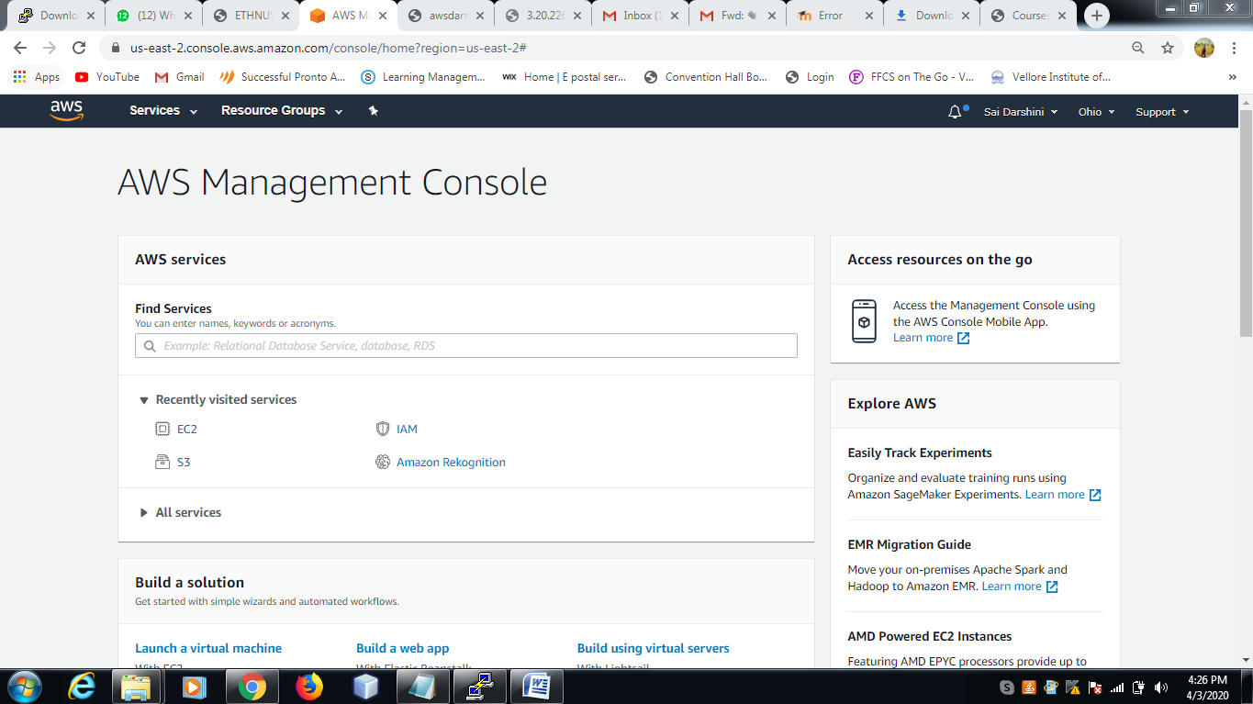

**2. EC2 Dashboard**

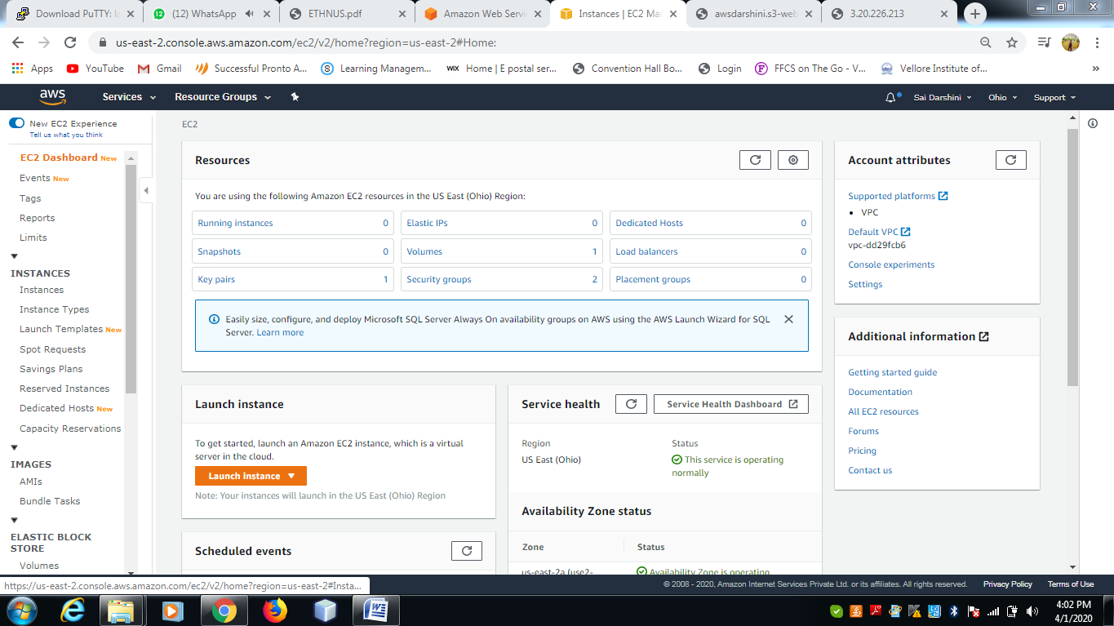

**3. S3 Dashboard**

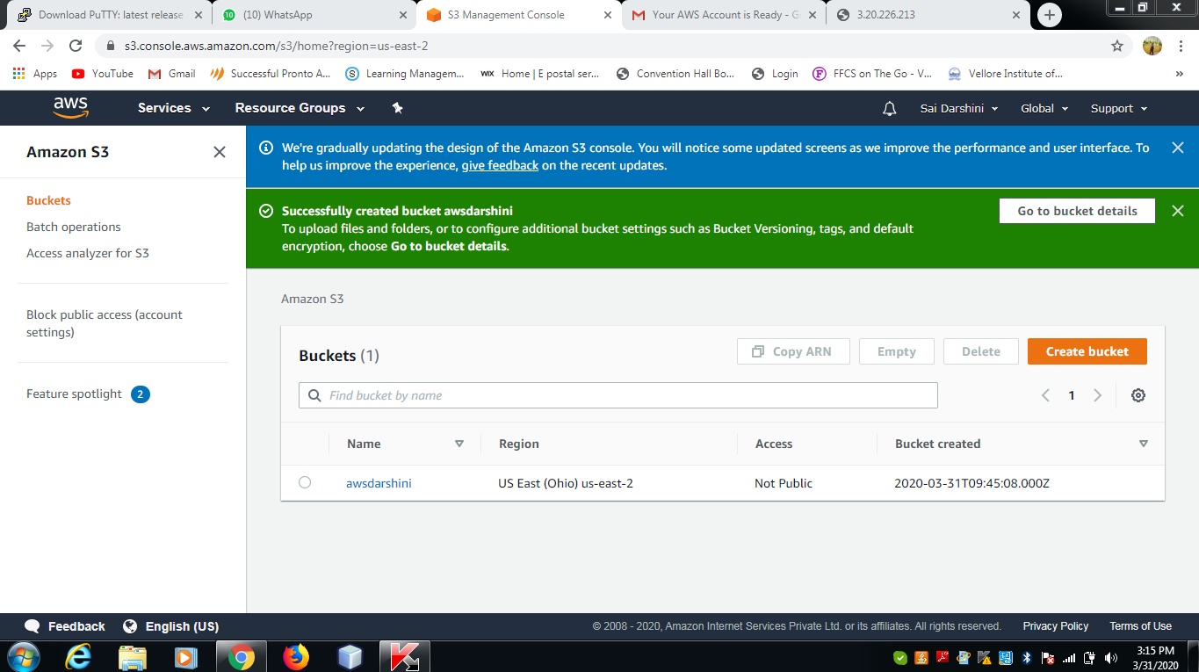

**4. Rekognition Dashboard**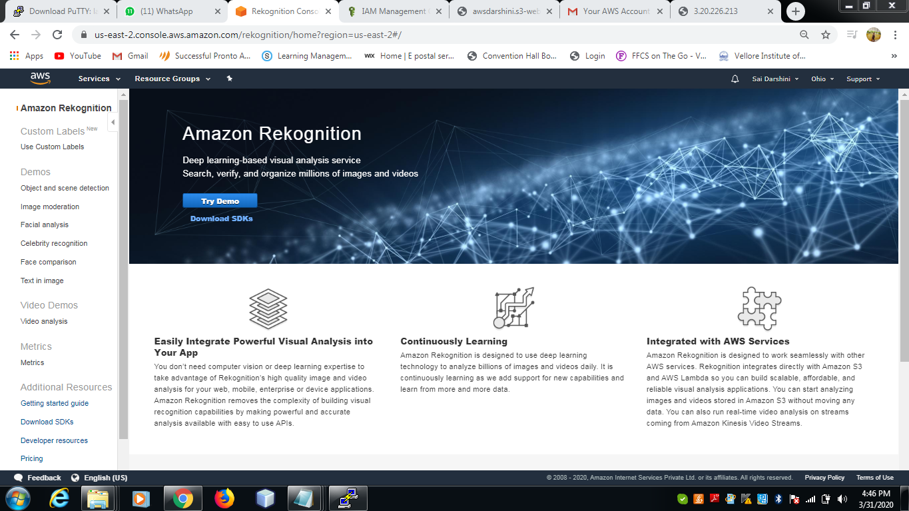

**SCREENSHOTS FOR EC2:**

**1. Choosing an AMI**

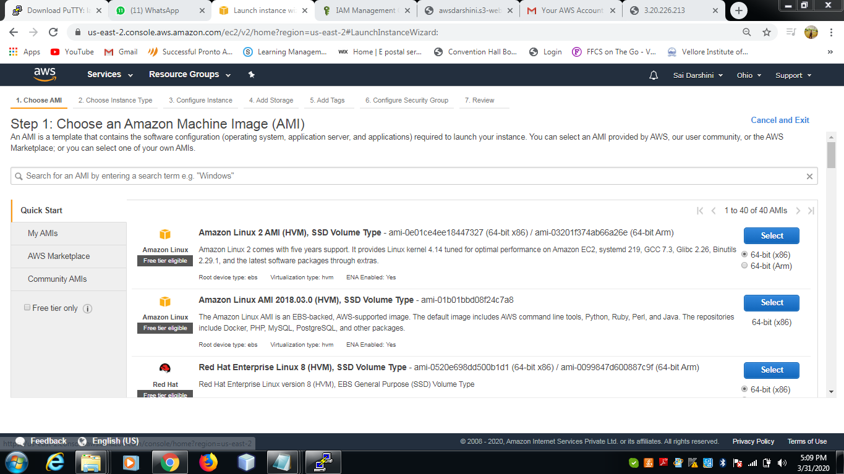

**2. Choosing an Instance Type**

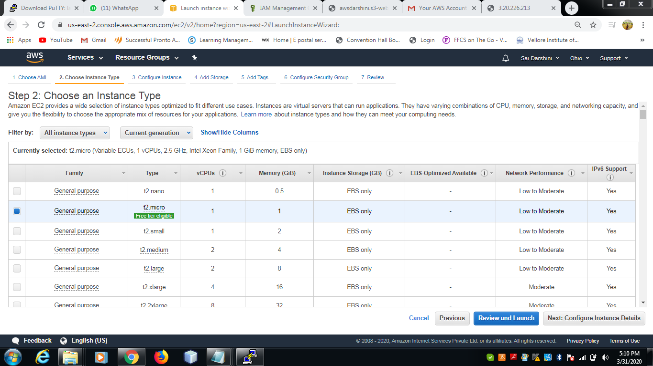

**3. Adding Storage**

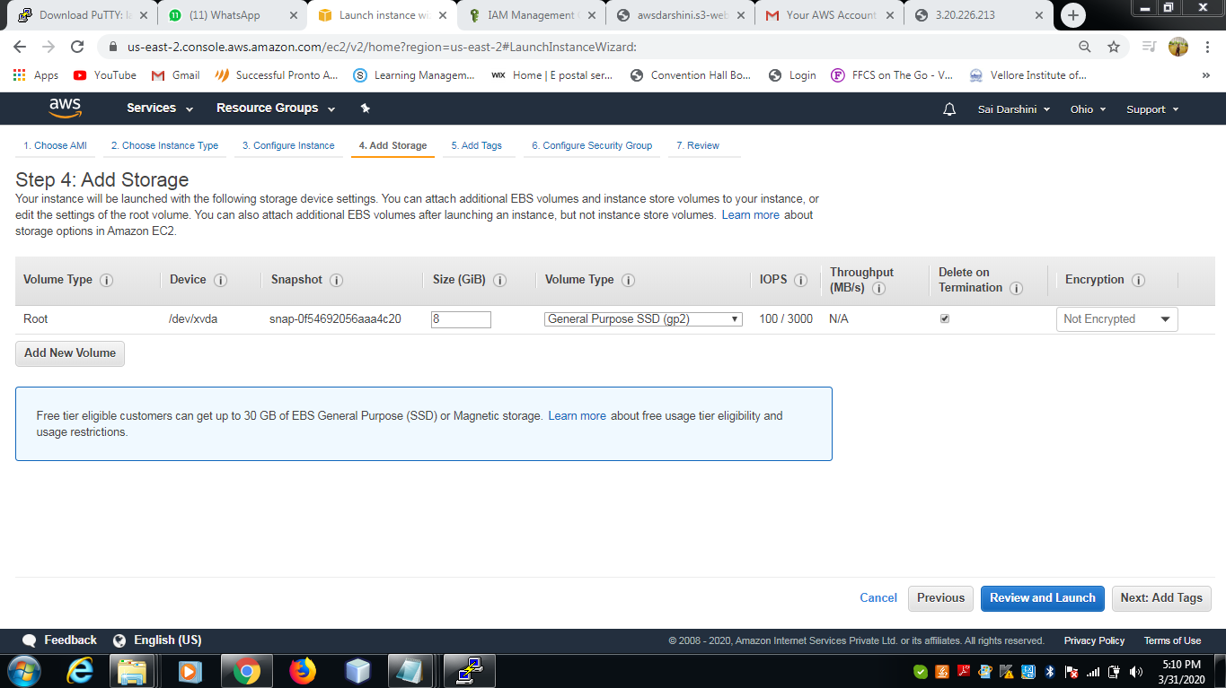

**4. Configuring Security Group**

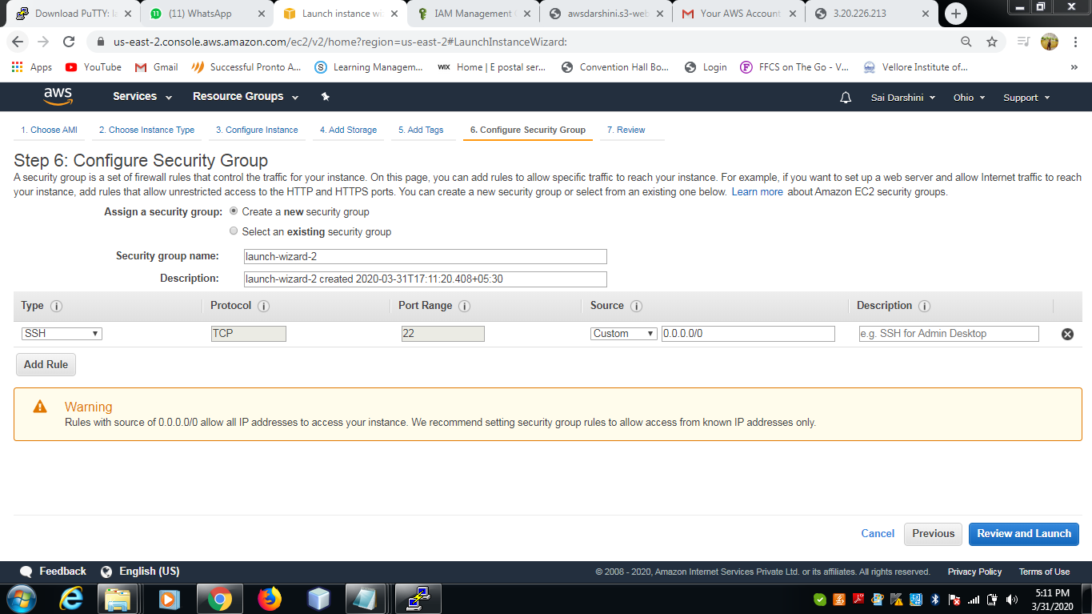

**5. Key Pair Download**

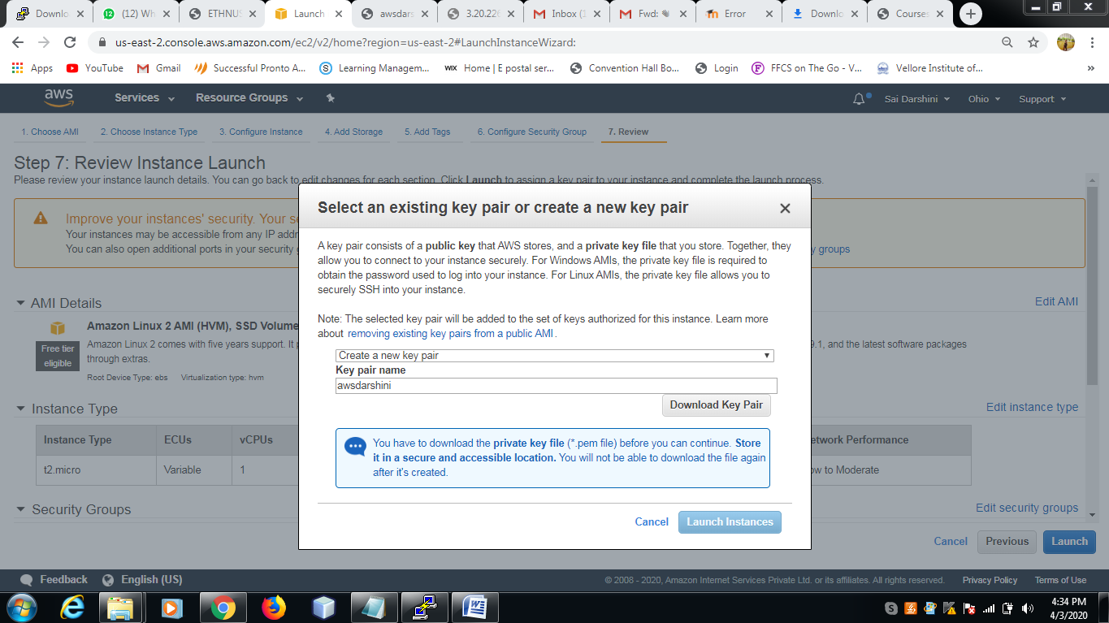

**6. PuTTYgen conversion from pem to ppk**

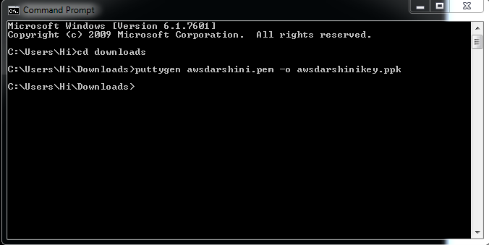

**7. Logged in EC2 black screen**

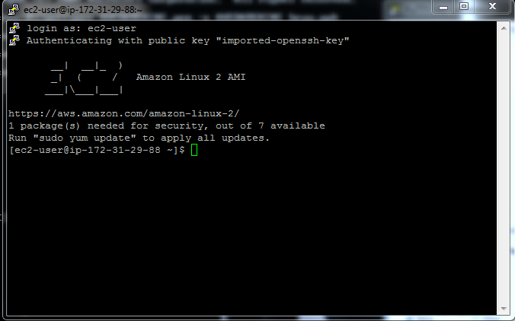

**SCREENSHOTS FOR S3**

**1. Creating a bucket**



**2. Uploading an Object**

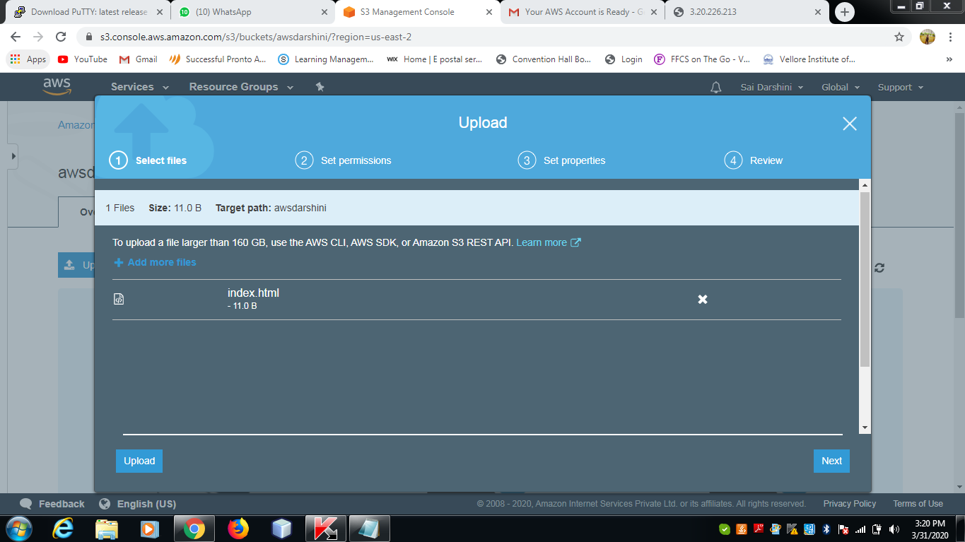

**3. Enabling Static Website**

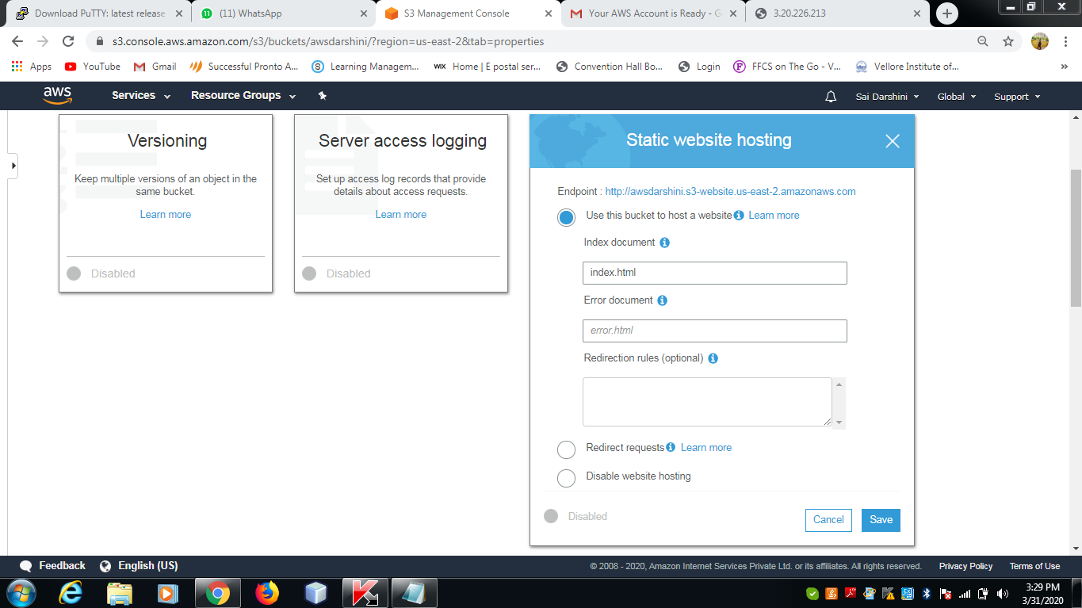

**4. Making the Object Public**

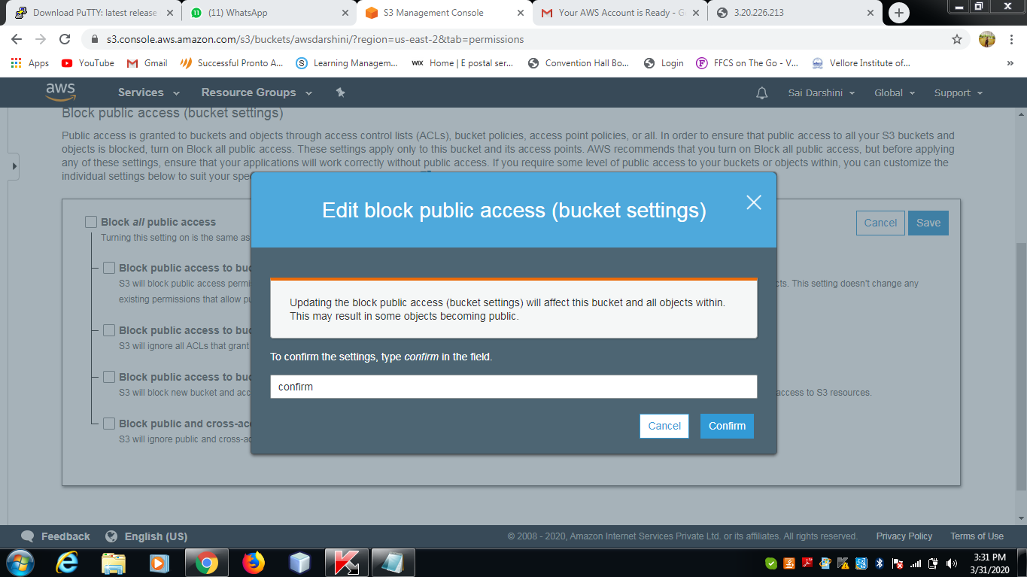

**5. Checking the S3 link on the browser**

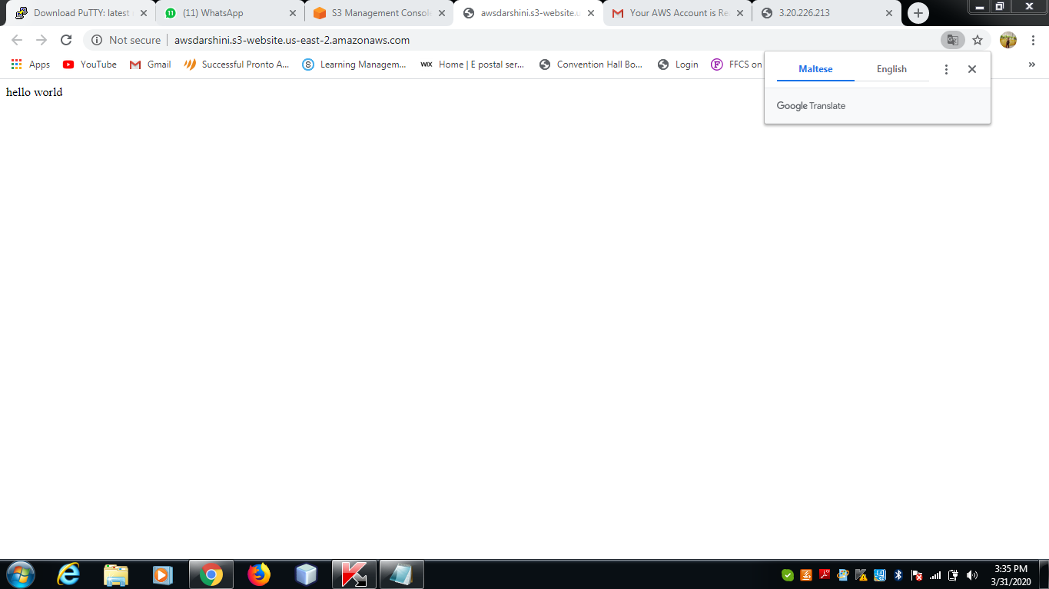

**SCREENSHOTS FOR REKOGNITION**

**1. Face Detect**

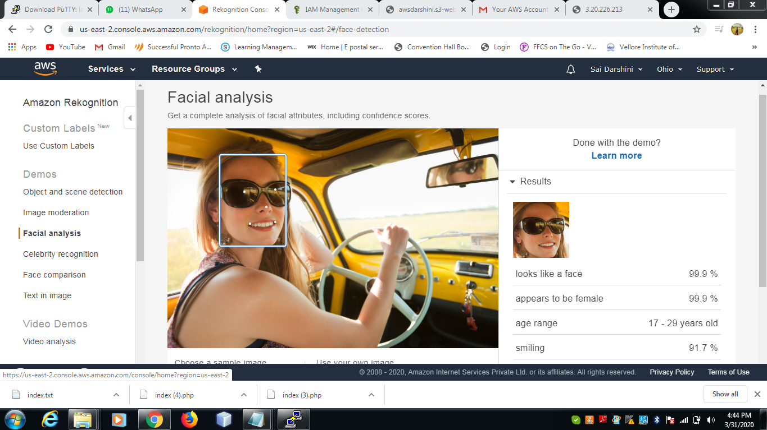

**2. Face Compare**

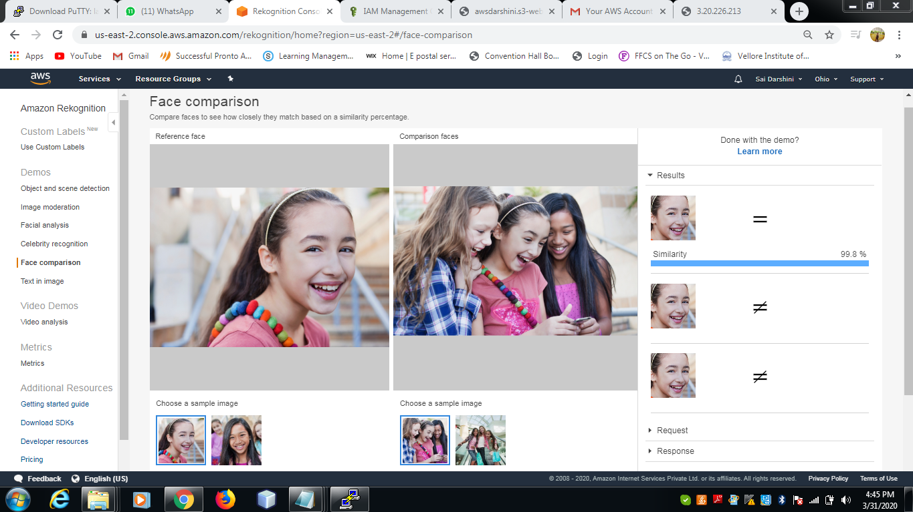

**3. Celebrity Recognition**

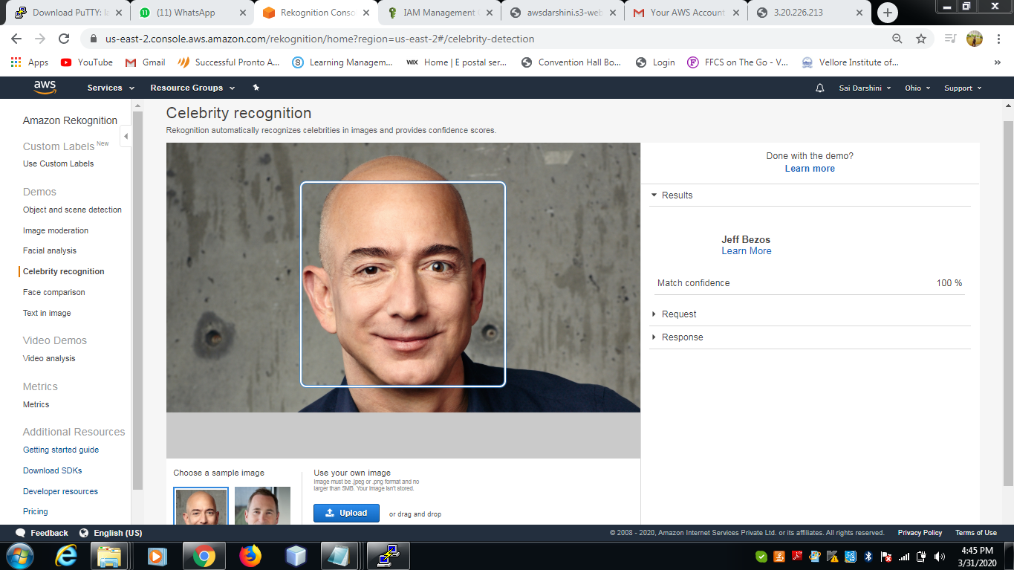

**4. Text in Image**

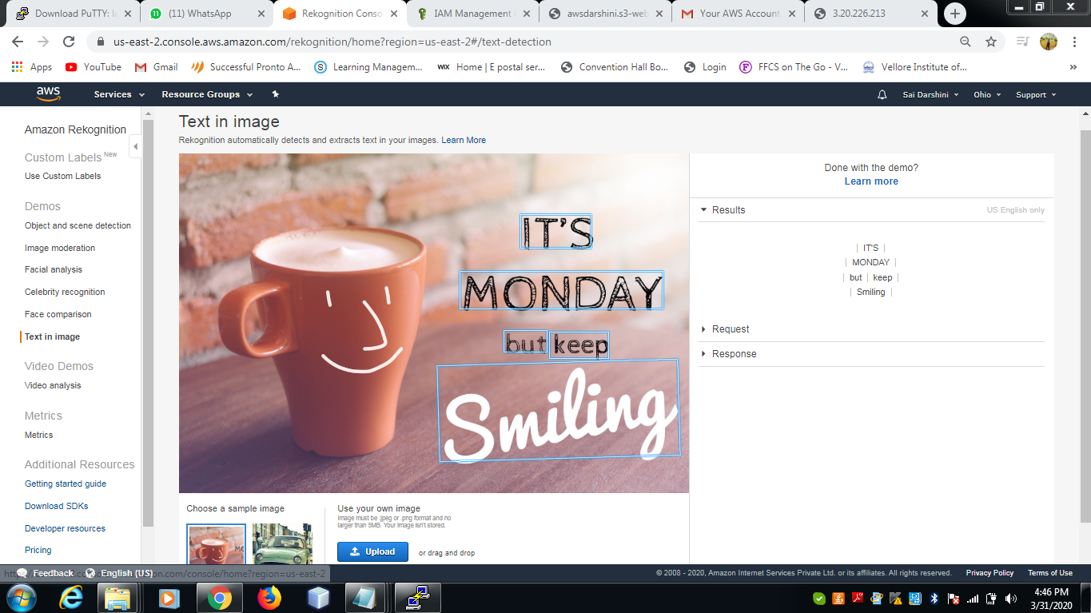

**SCREENSHOTS FOR EC2 & S3**

**1. Installing aws-sdk**

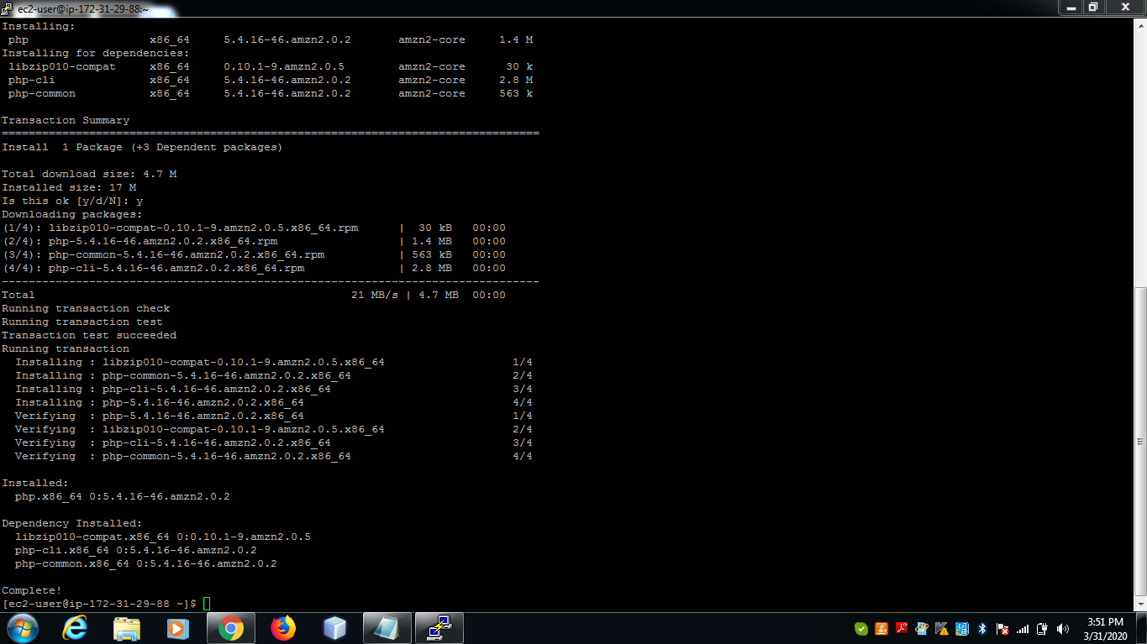

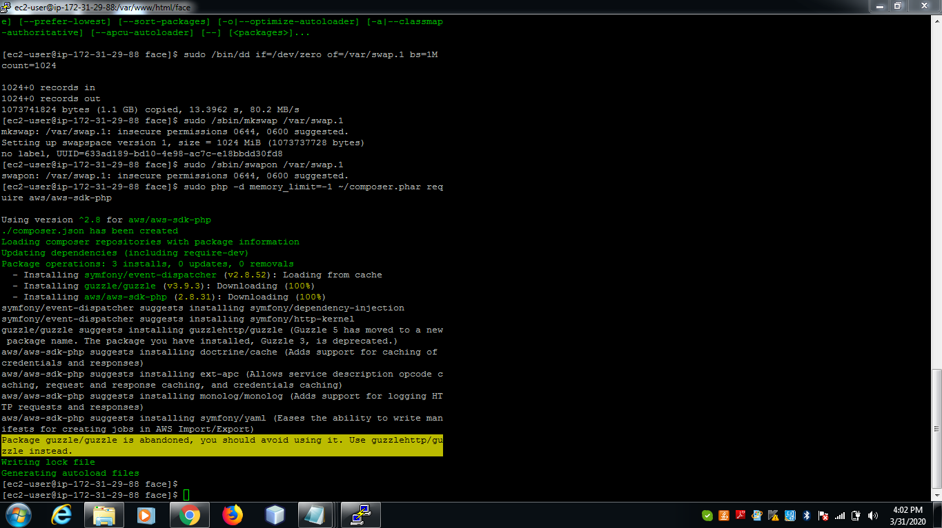

**2. Installing php**



**3. index.php file code**

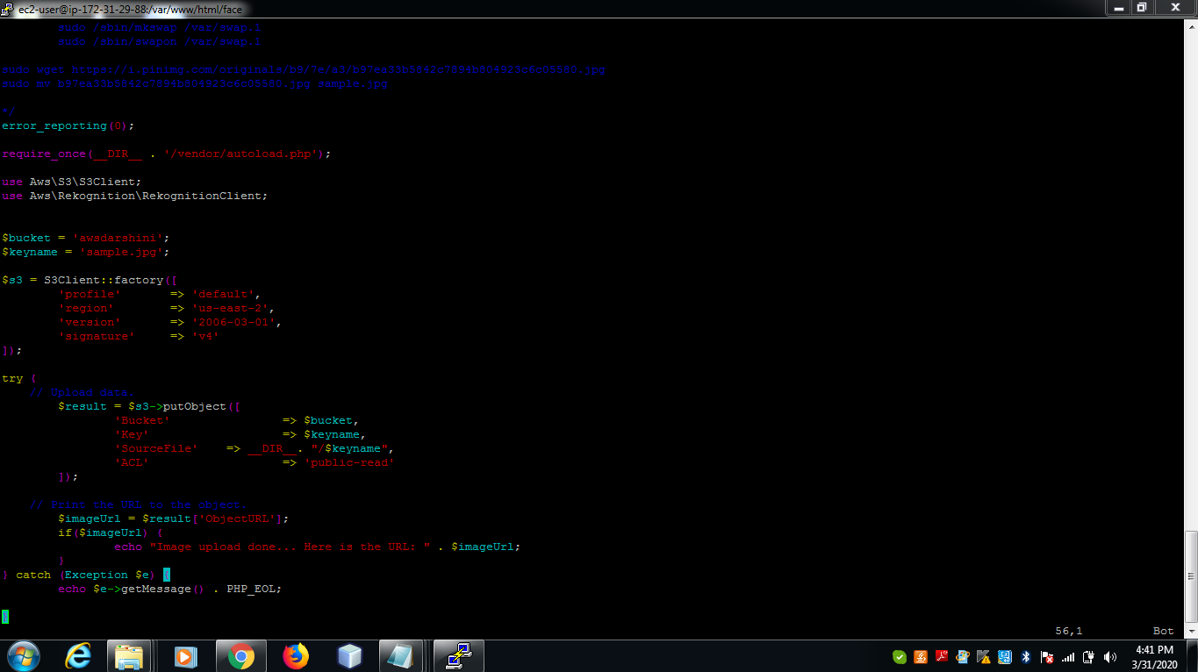

**4. success screenshot**

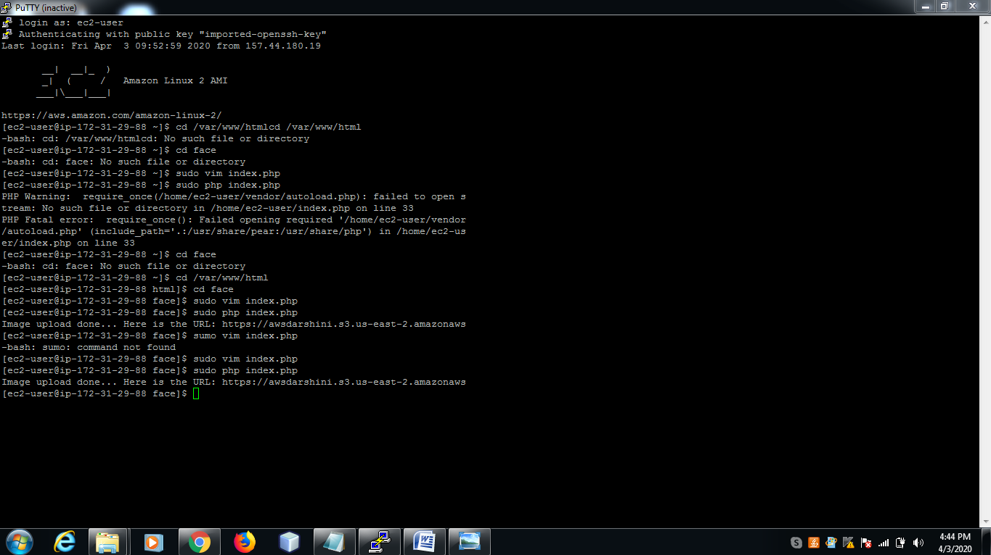

**Screenshots for EC2 & Rekognition**

**1. Face Detect success screenshot**

